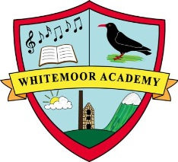
Class 2 2018-2019 Curriculum Map
Autumn Term | Spring Term | Summer Term
*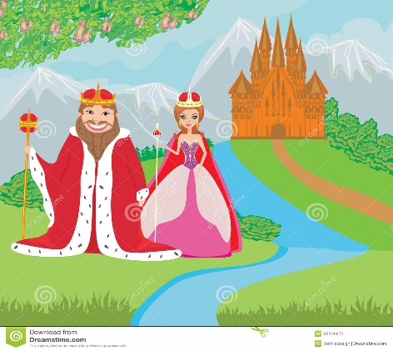  Kings Queens and Castles | 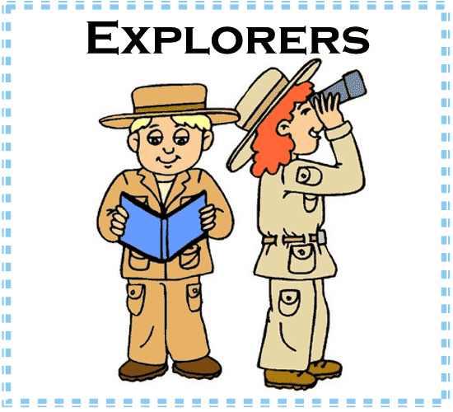  Explorers | 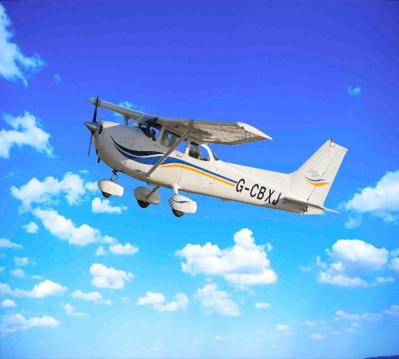  Flight
Compare the lives and reigns of Elizabeth 1 and Queen Victoria, two fascinating monarchs. Place their reigns and significant events within a chronological timeline. Identify the key roles of a monarch and facilitate further learning about these fascinating characters through a range of exciting and interactive activities.  Discover the castles around the British Isles! Find out about the most splendid castles and their locations around the UK. Capture the range of architecture using different art and craft techniques  - Learn about the lives of significant individuals in the past who have contributed to national and international achievements.  - Compare aspects of life, identifying similarities and differences between different periods.  - Develop a wide range of art and design techniques in using colour, pattern, texture, line, shape, form and space.  - Use drawing and painting to develop and share their ideas and imagination.  - Compose sentences orally before writing them.  - Re-read what they have written to check that it makes sense.  - Write for different purposes.  - Use simple punctuation accurately.  - Identify the features of a command.  - Order pictures of some significant/famous English/British monarchs on a timeline.  - Identify the key roles of a monarch and write them in the form of a job description.  - Begin to develop knowledge and understanding of the life and role of Elizabeth I through images, role-play and stories.  - Explore the significant developments of English life during Elizabeth I’s reign through mystery items.  - Make an Elizabethan collage using images from the time of Elizabeth I.  - Research information about types of medieval castles.  - Take aerial photographs of castle models and compare physical features with real castles.  - Create castles using junk modelling, considering the key features.  - Find out about life and jobs in a medieval castle.  - Interview each other for an imaginary job in a medieval castle.  - Use two-dimensional shapes to recreate a Paul Klee image.  - Describe/evaluate Paul Klee´s image Castle and Sun and their own work | - Develop historical knowledge and understanding of the lives and significance explorers including Christopher Columbus and Neil Armstrong. Identify the kit needed for an expedition and compare the equipment taken by Columbus and Armstrong on their voyages. Discover navigation techniques and learn about the materials used by Columbus and Armstrong. Identify the properties of a range of materials for your own expedition. Go on to describe your own ‘expeditions’ using a range of media.  - Learn about the lives of significant individuals in the past who have contributed to national and international achievements.  - Compare aspects of life, identifying similarities and differences between different periods.  - Use simple fieldwork and observational skills to study the geography of their school and its grounds.  - Name and locate the world’s seven continents and five oceans.  - Use aerial photographs and plan perspectives to recognise landmarks and basic human and physical features.  - Identify, name, compare and describe the simple physical properties and suitability of a variety of everyday materials, for particular uses.  - Use a range of materials creatively to design and make products.  - Write for different purposes.  - Segment spoken words into phonemes and represent these by graphemes, spelling many correctly.  - Participate in role play.  - Plan and go on a school grounds expedition with ‘Explorer Bear’.  - Locate some school grounds ‘landmarks’ in person and on a simple map.  - Order some significant explorers on a timeline.  - Label the 7 continents and 5 oceans on a map.  - Stick images of significant explorers onto the continent they explored on a map.  - Identify items needed to go on a successful expedition.  - Select time-appropriate items for ‘Explorer Bear’ to take on Christopher Columbus and Neil Armstrong’s voyages.  - Write a kit list for Columbus’s and Armstrong’s expeditions. | Learn about the Wright brothers and the story of their historic first aeroplane flight on December 17th 1903; find out about the history of flight and begin to understand how aeroplanes fly; consolidate your learning by using music and role-play to recreate the events of that auspicious day. Then learn about how the development of flight has changed the world we live in today.  - Learn about the lives of significant individuals in the past who have contributed to national and international achievements.  - Generate, develop, model and communicate their ideas through talking, drawing, templates, mock-ups and, where appropriate, information and communication technology.  - Design purposeful, functional, appealing products for themselves and other users based on design criteria.  - Evaluate their ideas and products against design criteria.  - Select from and use a wide range of materials and components, according to their characteristics.  - Explore and use mechanisms in their products.  - Use drawing to develop and share their ideas.  - Compose sentences orally before writing them, to use subordination and co-ordination (e.g. ‘and’, ‘then’, ‘because’, ‘if’).  - Note down key words and ideas.  - Write for different purposes.  - Evaluate writing with the teacher.  - Develop an awareness of the past, through finding out about changes within living memory.  - Develop an awareness of the lives of significant individuals in the past who have contributed to national and international achievements.  - Find out about changes within living memory and develop an awareness of the lives of significant individuals in the past who have contributed to national and international achievements.  - Give well-structured descriptions, explanations and narratives for different purposes, including for expressing feelings, participate in discussions, presentations, performances, role play, improvisations and debates.  - Participate in discussions, presentations, performances, role-play, improvisations and debates.  - Maintain attention and participate actively in collaborative conversations, staying on topic and initiating and responding to comments.  - Perform simple tests, using their observations and ideas to suggest answers to questions.  Select from and use a range of tools and equipment to perform practical tasks [for example, cutting, shaping, joining and finishing.  - Understand the difference between fact and myth  - Act out the Icarus story and create a character dialogue  Find out about the ways humans have tried to fly in the past
Outcomes: History, Art and English Geography science

