2018-2019 Curriculum Map
Autumn Term | Spring Term | Summer Term
World War 2  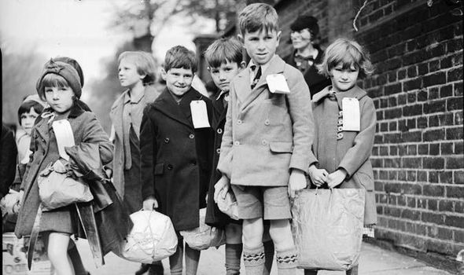 | Pole to Pole  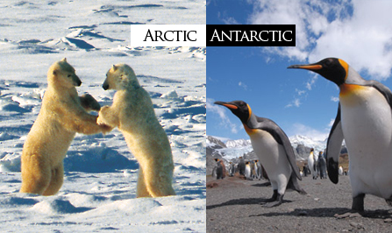 | Taking Control  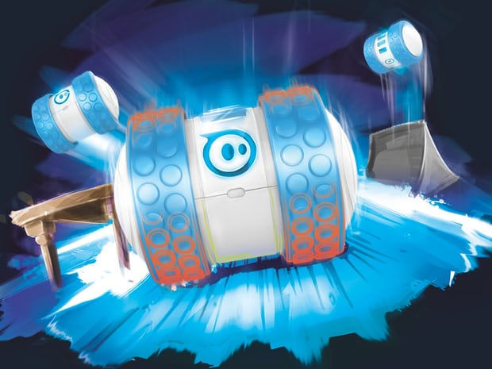
English  Evacuee Diaries - Goodnight Mr Tom  War stories - The Night The Bomb Fell  Instructional writing – War time Recipes  Poetry  Maths  Number and Place Value  Multiplication and Division  Fractions  Measurement  Statistics  Science  Classification of living things  Functions of human body  Life processes  Scientific Enquiry  Working Scientifically  History  Reasons for and causes of WW2  Living as a child during WW2  Importance of the Battle of Britain  Geography  Locational knowledge of Uk and Europe  Music  Listening to and singing popular music from WW2  Preparing and broadcasting WW2 radio programme with songs and news items  French  Greetings, numbers, colours, family members  Art/ Design Tech  Baking using rationed ingredients, designing shelters,  Designing propaganda posters  Periscopes  RE  Hinduism –expression of faith and values  Christian values and commitments  How Christmas celebrated around the world  Homework  Reading  Spelling / Handwriting  My Maths  Revision  Core Values  Aspiration/ Spirit | English  Poetry – Kipling  Fiction – Myths  Text – Non-fiction/ information  Composition – Biography  Report writing Linked to science  Maths  Number – Decimals  Number – Percentages  Number- Algebra  Measurement – Converting Units  Measurement – Perimeter and volume  Number- Ratio  Science  Friction as a force that opposes motion  Gravity as a force that attracts  Drag and Resistance  Altering Force  Properties of materials  Changes is state  Scientific Enquiry  Working Scientifically  History  Explorers of the past – Exploration of Scott and Shackleton as a significant point in British gistory  Geography  Locational Knowledge of the wider world - Using globe, atlas and map of the world and online maps  Understanding Latitude Longitude, Equator, Arctic and Antarctic circles  Physical/ Human Geography – describing and understanding climate zones/ settlement and land use  Music  Work on, listen to and compose music that relates to ice and fire  French  Where we live, animals, understanding of the world  Art/ Design Tech  Collage using a range of materials- representation of polar regions  Clay – animals from the ice caps  Sketching – pencil work  RE  The prophets in Islam  Importance to Muslims of stories of the prophets  Jesus in Christian belief  Homework  Reading  Spelling / Handwriting  My Maths  Revision  Core Values  Passion/Integrity | English  Writing newspaper reports  Story maps  Narrative openings, alternative conclusions and extensions  Modern legends  Explanation Texts  Maths  Geometry – Properties of shape  Problem solving  Statistics  Investigations  Science/ Computing  Electrical Circuits to create a ‘robot’  Light  Sound  Using sequence, selection and repetition in programs  Programming floor robots - Ollies  Music  Compose and perform electronic and synthesised music  Explore tone, pitch, rhythm, pace and dynamics  French  2D shapes  Understanding imperatives  Using connectives  Art/ Design Tech  Looking at work of Anthony Gormley and  Serena de la Hey  Considering the impact of giant sculpture in human form  Altering originals  Creating life size 3D Model in human form using recycled material  RE  Core beliefs and practices in Sikhism.  The 5 Ks of Sikhism  Saintly Living and what Christians can learn from the saints  Homework  Reading  Spelling / Handwriting  My Maths  Revision  Core Values  Resilience/Excellence

