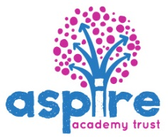
Whitemoor Academy - Assessment Results -2017

Early Years

2017 | Whitemoor |  |  | National
Good level of Development | 80 % |  |  | 71%
EYFS Score | 35.3 |  |  | 34.5

Phonics Screening Year 1

Phonics Year 1 |  | Whitemoor |  | National
Expected Standard | 88% |  |  | 81%

Key Stage 1

KS1 | Working within the end of KS1 expectations and above |  |  |  | Working at a greater depth within the end of KS1 expectations
 | Whitemoor |  |  | National | Whitemoor |  |  | National
Reading | 92% |  |  | 76% | 24 % |  |  | 25%
Writing | 83% |  |  | 68% | 21% |  |  | 16%
Maths | 92% |  |  | 75% | 24% |  |  | 21%

