
How this document is to be used:
The children have been set pieces of homework to last over the term.
The children can pick and choose the activity they would like to do each week. House points will be rewarded for each submitted piece of homework based on effort.
Homework is to be submitted on a Friday each week this can be done through Google Classroom or in their homework book.
Your child only needs to do one piece of homework a week from the grid, alongside their spellings and times table practice. Have fun 😊
Homework Grid
Whitemoor
Academy

Take a look at your topic web for the Autumn 1 term and write a paragraph or two about what you are looking forward to learning about the most.  3 house points | Create a poster about any famous battles that the Romans had. Give information that you have researched such as dates, locations, armies, tactics and outcomes.  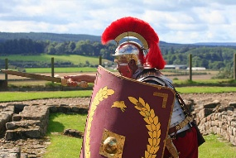  2 house points | To help you remember the place value of numbers, create some part-part whole models that show the value of each digit in each column. See below for an example.  1 house point  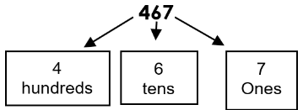  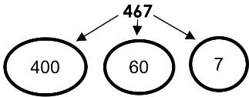
  Research touch rugby and watch some videos that show you the different skills within the sport. Bullet the skills and what you have learnt.  1 house point | Write a poem about your chosen Roman god. You can do this in whichever form you choose.  1 house points |   Our PSHE topic is me and my relationships. Create a relationship booklet that shows who you have relationships with and what they are to you.  1 house point
Imagine that you are a soldier in a battle for the Roman army. Write a diary about what you might see, hear, smell, touch. Describe your experience.    3 house points |   Experiment with different sounds. How can you make different sounds using the same equipment. Can you change the tone or the pitch? Can you alter the sound using different striking techniques?  1 house point | Research the Hindu religion and make some key points to educate others in the class.    1 house points
Aspiration- Write three things that you would like to improve at this half term.    1 house point | Write a conversation between two people in French. See if you can remember how to greet people.  1 house point | 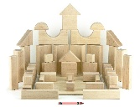  Using any materials you have at home, what structures can you create? They could be buildings, bridges or any other human-made creation that you can think of. Take pictures.  2 house points

